A remote interview between Kari Nevalainen and painter Vaughan Warren
You told me that you were lecturing fine art painting in Finland, that you had eight adult students with you and that this wasn't your first time here in my country. Now, that definitely sounds intriguing: a British HiFi enthusiast teaching fine arts in Finland! Your students, did they come from the UK or Finland? Tell me briefly about your background and the connection to Finland.
Seven students eventually made the trip, all mature ladies of about 60 years of age. They attend my adult education program run by our gallery, The Penzance Art Gallery on 1 East Terrace, Penzance, Cornwall UK TR18 5HU. Six came from North Cornwall, one from London. As to myself, I am the international painter Vaughan Warren RAS (Royal Academy Schools). I was trained at The Royal Academy London from 1978 to 1984, studying painting and anatomy. However and as in all things, one rejects all that is forced upon us only to review the experience much later as a way of testing and forcing the issue -- as a fine artist in my case -- to find one's own way. This path has contained many risks concerning questions like "is this activity normal" only to find the answer to be, "without confronting my own questions about why am I here, I wouldn't be me!"
Paint and my explorations of its abilities and mysteries define who I am - as do the mysteries of vintage electronics and audio engineering in my search for the definition of an emotional, ambient experience that recreates how other people use music like I use paint. I want to know how they feel.
I originally came to Finland with my first wife who, whilst at Helsinki Uni, left me to discover Finland. I sought out the painters who created the sense of Finnishness -- Hallonen, Gallen Kallela.-- but also the landscape specially around Munkannimei (sorry about the spelling but it is the place where the #4 tram stops by a café overlooking the frozen sea which always reminds me of the Russian 2001 film Solaris reinterpreting Tartosky's 1969 original).
The obvious next question deals with HiFi as a technical enterprise and Fine Arts or Art in general. Do you see/feel any affinity or contradiction between the two ambitions? What's the common denominator? For background, there are quite a few philosophers who take an interest in HiFi and that may be equally unexpected. I once posed a similar question to Prof. Jules Coleman from the Yale University who replied:
"Philosophy is about understanding ourselves, the world and our place within it. I would have thought access to music in our lives provides much of the same thing. Now it is true that many of us who are professional philosophers are also drawn to audio as well as to music, and that may be because we are drawn to the philosophical questions about the difference between music and its reproductions - the constitutive elements of the former and their relationship to the latter. Also, audiophilia is a discipline that allows for ongoing criticism and nothing makes philosophers happier than finding faults. And audiophilia is an incredibly analytic discourse filled with concepts and fine distinctions: neutrality, transparency, imaging, resolution. Nothing makes an analytic philosopher happier than to reflect on the criteria for the proper application of concepts."
 |  |  |  |  |  |  |  |  |  |  |  |  |  |  | Painting poses questions about our critical faculties - how do I know this is any good? The question is to oneself, not whether anybody else likes it. Other people give feedback which one assimilates but I must understand for myself and please my own critical faculties before I can judge or value the opinions of others.
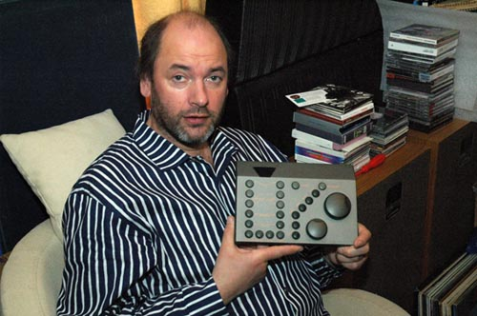
 |  |  |  |  |  |  |  |  |  |  |  |  |  |  |  | HiFi -- or as I prefer, musical reproduction devices -- pose the same questions. How do I know this is what the musical artist intended? Is this how they want me to feel? Do I feel something that others feel as well? Does it really matter? Of course it does but I am always
aware that understanding might be the result of misunderstanding. Although I know it to be inaccurate, I might like the sound because it changes meaning as does a chance mark or color. It wasn't what was intended but it makes me feel really good -- I look at, see or hear things in a new way -- and that's what makes life an individual experience, unique and yet at the same time connected to that mass of humanity; something expressed in paint and music in similar ways through layering, tone, depth and spatial placement. So those are some of the formal requirements. There are also the subjective values - emotional impact, meaning, relevance; the ability to travel in one's mind to a place of sublime beauty; aesthetics; the wonder of order from chaos; the utter irrationality of how it all makes such good sense for our own wellbeing.
I agree with your professor from Yale who defines the parameters well but there are abstract contradictions which one must rationalize into a definite term but which escape absolute meaning - that sense of absolute rightness which I thought unattainable until I took a serious journey into great audio engineering principles from the past (Klipschorns from 1946, Quad Electrostatics from 1957).
You said that you own eight systems? Is that in a sense that a cat has nine lives or literally? If the latter, does that mean that you cannot decide what you want; or that you don't really believe in a so-called universal HiFi systems that can reproduce allmusic in an equally consistent manner; or is there some other justifying reason for having so many different systems?
I have eight different systems which can be considered separate systems in their own rights. The source may be analogue or digital but amplification is usually dictated by the loudspeaker component. I was collecting vintage or retro equipment in an ad-hoc fashion at first until a friend of mine invited me to help him make sense of his collecting obsession. It was perhaps a bargain, merely interesting or something else altogether. Regardless, I decided to rationalize things. I would try to collect prime examples of the best technology from any given period to define the sound I wanted to hear.
 |  |  |  |  |  |  |  |  |  |  |  |  |  | 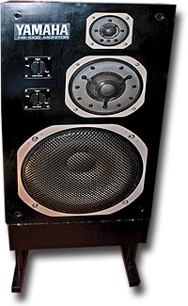
Loudspeakers were a good place to start - horns, electrostatics, infinite baffles, phase arrays, dispersion, ported designs, auxiliary bass radiators, stacked pairs, inverted pairs... However, as I identified great speakers, I became aware of their performance being dependant upon appropriate amplification -- Class A, Class AB,
Class D, transistors, valve ( I don't believe one is better than the other, only that one is more appropriate to best performance in certain setups) -- and then of course the question, was British better than Japanese or American.
The strange thing is that although I longed for the one system and have found several I could live with if all else failed, I enjoy the choices and nuances that differing combinations can give. This operates on an almost emotional level. I play the system that conveys the music which I want to hear in the way that I want to hear it. This is not so much about inaccuracies in sound reproduction but rather, whether a certain system may be more analytical of a bad mix which enables you to hear more. Conversely the same system may overanalyze a mix so that the music falls apart. The composition falls apart as in a painting that doesn't seem to work.
So here are my eight systems or combinations, not in order of preference though I will indicate my favorites.
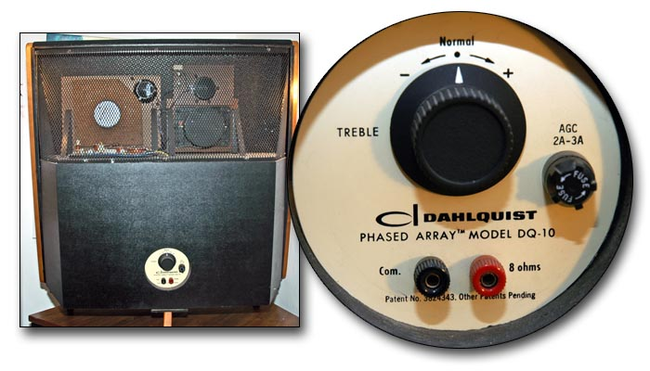
- Quad System 66: Quad CD67, Quad 66 preamp, Quad 66 FM tuner, Quad 606 MkII power amp, Quad ELS 63 - a very well balanced system.
- Japanese High End: Analog/digital sources followed by Denon DAP 5500 preamp and Denon POA 4400A monoblocks and Yamaha NS1000m speakers - amazing power from class A amps.
- American Esoterica - Analog/digital sources followed by two Sonic Impact T-Amps and Klipschorns - $60 amps driving 1947 technology but probably the best yet.
- British Vintage - Garrard 401 with SME 3009 S2 Imp (fixed head shell )and Shure V15 MkIIIHE into a Musical Fidelity X-LPS phonostage, Quad 22/II preamp/monoblocks into a stacked pair of Quad ELS 57s - is this the best? With real breathing vocals, it is alive.
- Phase Array - Analog/digital sources, Audio innovation prototype valve amp and Dahlquist DQ10 - a system with limitations but magical on the right material.
- 70's retro - Garrard 401/SME/V15 III with Quad FM4 tuner, Quad 34 or 44 preamp, Quad 405 MkII amp and Celestion Ditton 44 speakers
- Lowther System - Analog/digital sources , Quad 22/II preamp and monos, Lowther PM6a Acoustas - prior to the Klipschorns, the potentially most universal system.
- Digital source system - Shanling CD-T80, Quad 33 preamp, Quad FM3 tuner, Quad 303 amp, Wharfedale Diamond MkI speakers - small speakers but with amazing speed and imaging. Almost all you need but the diminutive size plays havoc on equating scale with performance.
- IT system - Apple G4 Powerbook with Wharfedale Diamond Actives - my system of choice for listening to Late Junction on BBC radio 3 on their Listen Again web page. Finnish music gets played often and their mix tells you a lot about my tastes in music - anything from noise to sublime electronic harmonics.
As you can see, it's quite a mix which sometimes gets shaken up. For example, the AI valve amp sounds great in a different way with the Klipschorns as does the Quad 22/Iis. Also, the Quad 33/FM3/303 combo gives the Yamahas real bass in true HiFi style. Above all, these systems all sound musical and I can go into more depth if your readers should wish at a later date.
By now I guess you wished you hadn't asked but it is truly fascinating how equipment of a certain vintage really delivers the goods and not for a lot of money. The Shanling CD-T80 is the only new item I have bought recently. Nothing else attracted me either technically or sonically. Perhaps I am reaching a point where the best will battle it out for supremacy in that one universal system? I do take a universal approach to all media in paint but then, I am in control of the delivery!
As you know, there are several approaches on how to put together a high quality music system? What's your preferred criteria?
I never tweak original system components apart from trying different cables and interconnects. I believe the design was the best the period could produce and anything introduced later would become a hybrid of a DIY mentality. The condition is not so important and this has led me to acquire some very rare stuff. As to your question, I believe I answered that in considering the requirements of the loudspeakers to perform at or above their design potential based on the amplification components. I admit that I take the Garrard 401/SME/V15 III combo for granted but that's because it delivers everything I play on it to a standard that enables all other components in the chain to exploit the signal to best advantage.
What role do aesthetics play when you select your gear?
None - although a small speaker delivering a grand performance doesn't really work. The illusion is shattered and you fall out off the grip of musical grace. However, nothing I own looks boring. I think this is due to my insistence on design diversity as a criteria, to locate that perfect system which of course does not exist - as does perhaps the perfect performance. I would not want to achieve the perfect painting because then the journey is over.
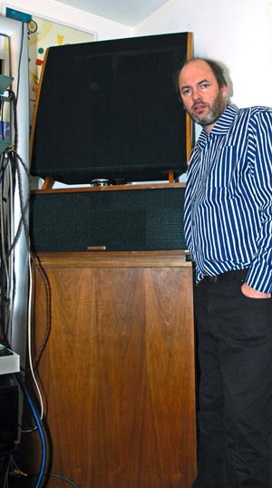
 |  |  |  |  |  |  | Your present system revolves around Quad 22/II valve amplification driving stacked Quad ELS 57s sourced by the Garrard 401 for analogue and the Shanling CD-T80 for digital.
That's a really cool system. I know because I once had a similar system except that instead of the Garrard, I had the EMT 930. What does it mean to you that the system is almost half a century old?
It is older than I am. I respect that. That it delivers a sound that can meet the demands of digital proves how right it is. It has a sensitivity to human emotions and conveys that. It's alive.
Name three things (properties of the sound) that the system does really well?
It breathes with the singers. It has a sense of scale - one moment it's quiet and still, the next there's instant thundering cacophony and massive crescendos. It takes all music in stride. Don't forget, two Quad ELS57s per side move the air in the room and are not so constrained by room dynamics.
Some specific questions: Is there a Decca/Kelly ribbon tweeter in-between the stacked ESL 57s? Have the Quad IIs gone through some modification, and if so, what? Have you ever tried subwoofers made for specifically Quad 57s such as the one by Gradient of Finland?
No. I think Mark Levinson suggested this. I find no need for it as there is air and space aplenty. The Quads are going in for service to the excellent service department Huntingdon as they appear to have gone live - I can't turn them off unless I unplug them. Otherwise they are in original condition. Closely matched production pairs - this I feel is important. All original Mullard and GEC valves in the amps.
Funny you should mention Gradient as I was after a pair of subwoofers for my ELS 63s. I know they were made in Järvenpää near Pekka Halonen's villa by lake Tuusula (forgive my lack of correct spelling as I am trying to answer these questions in the same frame of mind - jumping away to check spelling spoils the flow ). I went to a second-hand HiFi shop in Helsinki and was met with a quizzical look.
As to the Garrard 401: How would you argue for the 401 over the 301? Did you experiment with different plinths? Which tone arm and cartridge you use?
I first heard the stacked Quads with a 301 through Viva valve amplification. I must say that the 401 with the SME/Shure comb is a solution that works because of its balance. The 301 through the Quads delivered a subtle rumble which spoilt the effect. I am always surprised how good my hearing is for my age. My 401 sits in a home- made solid wooden plinth with no feet. It is superb!
 |  |  |  |  |  |  |  |  |  |  | 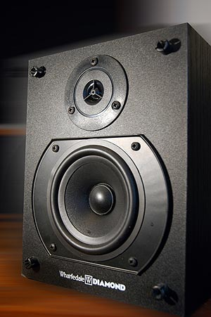
You indicated that you're thinking about purchasing some Klipschorns or Klipsch La Scala I or IIs. Is that because Quads are somewhat limited in their capacity to reproduce music's dynamic variations? Or is it because of a love for hornspeakers in general?
I think it comes down to either planar or horn technologies. I dispute that the Quads lack dynamics as mentioned earlier. Perhaps it may have more to do with the sheer physical presence of the Klipschorns - but I could never part with either. Interestingly, the fact that the Klipschorns fit into corners maximizes the available space in my relatively small room.
What's your preferred sound?
All my systems deliver detail with musicality with varying degrees of emotional involvement. The Quads are embarrassingly good to make you feel no barriers with the performer.
How would you comment on the idea that the sonic properties of reproduced music we are after in this hobby are desirable precisely because of the total absence of visual perception? That the essence of this hobby mean a sound without blood and flesh, a kind of immaterial sound?
 |  |  |  |  |  |  |  |  |  |  |  |  |  |  |  | No! At this level we are at the level of illusion. Close your eyes and there is a presence in the room which can be very scary. Open your eyes and the illusion is obviously lost because of the visual distraction. In painting, I tell my students that any suggestion is stronger than actual depiction. The mind fills in the detail if coaxed sufficiently. Perhaps this is how a good HiFi works?
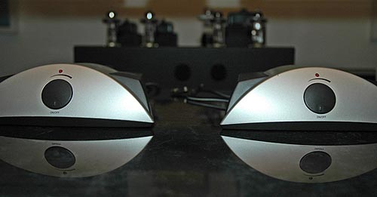
 |  |  |  |  |  |  |  |  |  |  |  |  |  |  |  |  | What do you make of the home theatre hobby? Does the
picture spoil the spell of the artificial abstractness of the two-channel music listening and what is achieved by fine-grained sound manipulation alone?
The cinema sound is great but it is another application of audio. Personally perhaps a film plus the audio performance in-between the speakers might be all some people want. I've tried quadraphonic setups and they fall apart. Forgive me but surround sound is a false world of accentuated bangs and booms. Music has a far greater range of complexities.
What's music to you? What music do you listen to for own pleasure?
Lou Reed. Joni Mitchell. Bjork. Miles Davies. Rautavara. Vartina. Lauri Anderson. Gustav Holst. Al Green. Tim Buckley. Tom Waits. Led Zeppelin. Norah Jones. Burt Bacharach with Elvis Costello. Linda Krall. Nico. Eno. Bryan Adams. Peter Gabriel. Etc. I have around 400 LPs and as many CDs. I abandoned tapes of any kind and do not download music. My mood at any one time could produce many differing favorite tracks so I won't make a definitive choice.
As you well know, Kandinsky wrote much about the relationship between music and visual art and many other artists have stressed the close relationship between the two. What's your position on this?
I never listen to music when I paint as I would then be recording in paint my emotional response to the music which would have to be conveyed to the viewer through an accompanying system as they view the painting. Then where would we be? It would have to be the same system to convey every nuance!
The great painter Titian said that a painter should not wish to be a musician and vice versa - each chasing the chimera of excellence in their own mind. I respect Kandinsky immensely but his writings are merely his opinion. With respect, I value my own opinions equally. I have to. It's my mind that I try to understand based upon all the information it absorbs.
Is "musicality" to music what "beauty" is to Fine Arts? Or is speaking about beauty a too vague way of using language in this post-modern era?
Beauty is a constant in the mind of the person viewing or listening. It is, however, different for everyone so there can be no absolute beauty except for every individual that seeks it. Many may agree to agree that something is beautiful but just as many may not. Fortunately, the arts are not a democracy . We are our own dictators of taste.
I equate beauty with pleasure. It's a reaffirmation that I am alive and can enjoy the exquisite pleasures my senses bring me while I am able to engage them in my profession..
 |  |  |  |  |  |  |  |  |  |  | 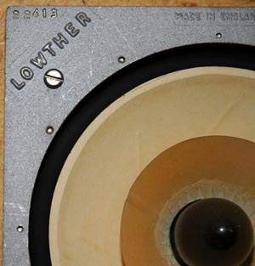
If I lost my sight, the music would restore my vision through my mind. I cannot conceive of a worse tragedy than those so
unfortunate as to have never seen and to be unable to visualize in their mind serenity and sublime peace. What do they see - colors or the trace of ancestral memories? What is Swan Lake like to a person blind from birth? What do they visualize without a concept of an orchestra? What do they do? However, it however makes no difference to their emotional response. It speaks of life and death in an abstract way, a human/animal ordeal.
What's your definition of art? What makes something a work of art?
If I say it's art, it is - it is for others to say it is not. Andy Warhol is very good at these games. I believe that a creational experience goes beyond the prescriptive consciousness of the person creating it is. Although as artists, we strive to move forward, we cannot always know just how we arrived at this new place and how an inner concept was made real.
When I paint a picture, it stops me to think that a moment ago, this did not exist. Therefore it has come from my unconscious into the material realm of the here and now - and it may even outlive me!
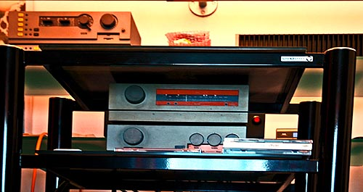 |  |  |  |  |  |  |  |  |  |  |  |  |  |  |  | Is there any reason why we should not regard HiFi as an art form, an art of listening to music created by microphones and controlled by the listener through his sophisticated and ultra-sensitive stereophonic home playback system? An art of listening to music that is based on sound discriminations that are unavailable in live spaces? I'm referring here to Glenn Gould's famous article in High Fidelity.
I have not read this piece so I will seek it out. However, the art of reproduced music is experienced in the mind as is painting. So on one level, I refer you back to my answer on beauty. But the assemblage of HiFi components could be conceived of as organic sculpture -- nest building or a momento mori -- as even in the midst of paradise we are in death, with all art transitory though some components last longer than others. Listening to HiFi is also a solitary activity as is painting. Perhaps it is a personal expression of achievement?
I know I should not ask this but ... what's your honest opinion of Finland?
I love Helsinki. It is cosmopolitan and stylish. The countryside drifts towards the arctic and fades yet Finland lingers in the memory and that is what I paint. On the other hand, I find Finland isolated in terms of Europe yet drawn more towards the East - which is refreshing yet must be frustrating to the Finns. The Internet has brought us into contact but it takes people to take it farther. That is why I came to Helsinki - to share my love of your country with other kinswomen of my own. It is also true that Finland's isolation is something to be cherished. It is a young country with ambition and choices to make.
At the next stage of compiling this e-mail interview, I posed some specifying questions to Vaughan that I wanted him to elaborate on a bit: Should I take it that for the first three listed systems, the source is the Quad CD67 and for the rest, the Garrard 401/SME/V15 combo?
My preferred CD reference is the Shanling CD-T80. By using a Musical Fidelity X-LPS phonostage, the Garrard 401 et al is incorporated.
 | Is there some sort of contradiction in what you say before and after the dash in the following passage? "I agree with your professor from Yale who defines the parameters well but there are abstract contradictions which one must rationalize into a definite term but which escapes absolute meaning - that sense of absolute rightness which I thought unattainable until I took a serious journey into great audio engineering principles from the past ( Klipschorns of1946, Quad Electrostatics of 1957."
 |  |  |  |  |  |  |  |  |  |  | 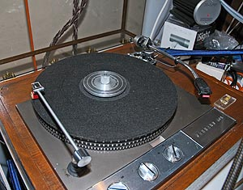
I don't believe there is a contradiction. What I am expressing in perhaps a less than clear way is that people attempt to label ideas which we accept as a starting point but remain dissatisfied with because some concepts exist beyond words - a smile on the face of a contented audiophile for example. It takes how many words to describe it?
"Certain system may be more analytical of a bad mix which enables you to hear more - conversely the same system may overanalyze a mix so that the music falls apart - the composition falls apart as in a painting that doesn't seem to work!" What mix are you talking about?
The mix is the mix of the music. Its constituent parts have to be combined to produce music. Yet some components are so analytical that they unravel the performance back to its constituent parts through exposing everything in detail. This demands so much attention that fatigue sets in as though one looked at a pre-Raphaelite painting and tried to absorb its Super Realism. System synergy is reflected by its ability to convey the illusion of a real/live performance.
"I never listen to music when I paint as I would then be recording in paint my emotional response to the music which would have to be conveyed to the viewer through an accompanying system as they viewed the painting. Then where would we be? It would have to be the same system to convey every nuance!" Here I'm not sure that I fully understand what you mean, and the same goes for the next passage. "What do they see - colors or the trace of ancestral memories? What is Swan Lake like to a person blind from birth? What do they visualize without a concept of an orchestra? What do they do? However, it however makes no difference to their emotional response. It speaks of life and death in an abstract way, a human/animal ordeal."
 | 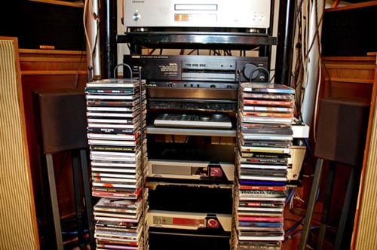 |  |  |  |  |  |  |  |  |  |  |  |  |  |  |  |  | If you paint to music played through a system, then to convey to the viewer how the artist reacted to the music to produce the work would require having to play the same piece of music back through the same system to allow the viewer to enter the world of the artist and his marks.  What I'm trying to suggest is that if a system can convey a sound that produces an emotional response, then it can reach deep into the psyche to release the touched-upon innate self. So if one was blind from birth without a conceptual knowledge of a lake of swans, a great system would unlock a response to it.
In a subsequent e-mail, Warren found the following quotation and felt it was a great statement about the passion great products evoke and that it gets very close to the matters on which we have spoken:
 |  |  |  | 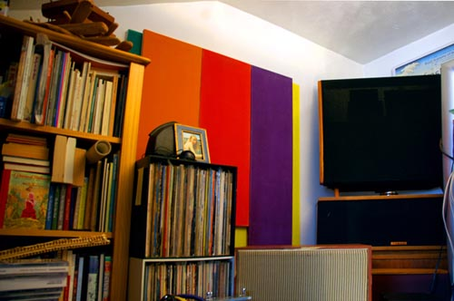
"In the world of audio, poor or mediocre products are numerous. They go along with larger systems designed to protect and promote trash. Standing apart from these are many 'good' products... which serve us well but can be quickly forgotten as is any worn-out appliance when its service is over. Finally, there are those very few great products, truly realisations on
inspiration, which, however obsolete, and though they may have passed from our lives, cannot be removed from our hearts. They are Industrial Art. They enrich our lives. The Klipschorn is one of them."
from ' First Encounter with The Klipschorn ' by David A Wilson ( WAMM Designer )
- Sound Bites : K. Kessler & S. Harris 2005, ISBN : 0-86296-242-0
 |  |  |  |  |  | 